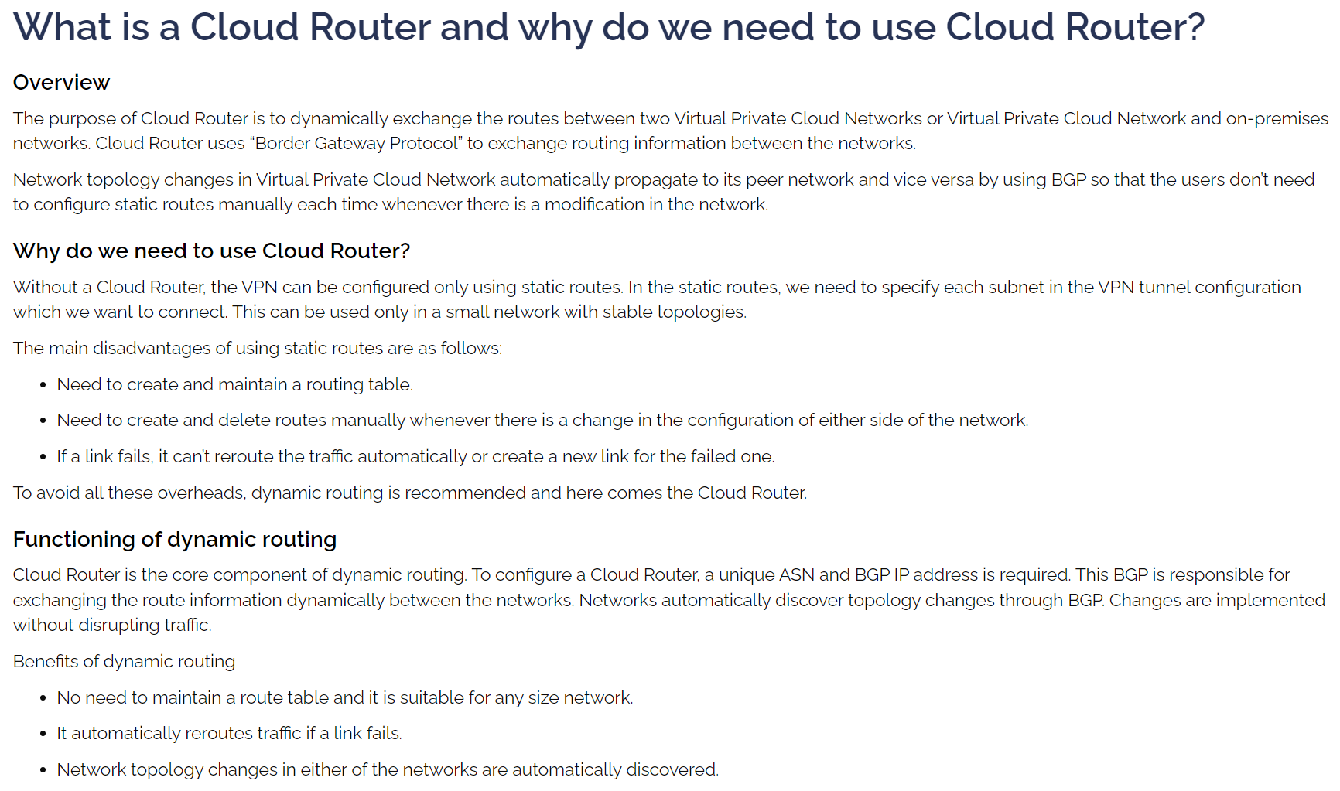

GCP to AWS VPN USING DYNAMIC ROUTING:

<https://cloud.google.com/architecture/build-ha-vpn-connections-google-cloud-aws>

<https://medium.com/google-cloud/dynamic-routing-with-cloud-router-9ff5c362d833>

<https://blog.searce.com/transit-network-made-easy-aws-google-cloud-fc236085e171>

While Creating New VPC Connection in AWS, make sure you have selected “Dynamic (requires BGP)” and provide Local IPv4 network CIDR(GCP) and Remote IPv4 network CIDR - optional(AWS)

AWS Customer Gateway for GCP VPN GW are added as below. ASN 64512 is added for GCP CGW:

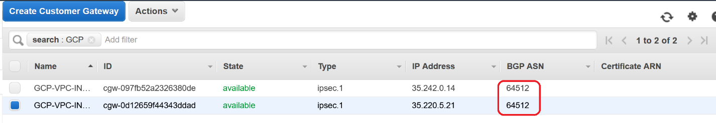

Following information can be found in the Network Configuration downloaded from the AWS VPN configuration:



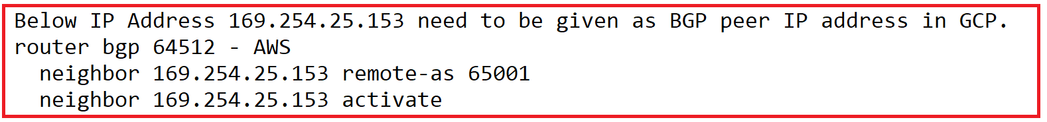

Large IP belong to GCP Cloud Router BGP IP Address (169.254.25.154)

Small IP belong to GCP BGP Peer IP Address (169.254.25.153)

GCP ASN – 64512

AWS ASN – 65001

After successful VPN configuration, following should be displayed.

